**The contribution of museums to preserving heritage and Algeria's civilizational development: A case study of the Museum of Ancient Antiquities and Islamic Arts**

**Mokaddem Mokhtaria** 1,and **Mokaddem Bentnebi** 2

1 University of Mustapha Stambouli- Mascara (Algeria), Email: [mokhtaria.mokaddem@univ-mascara.dz](mailto:mokhtaria.mokaddem@univ-mascara.dz)

ORCID iD: 0009-0001-4220-818X

2 University Abu Al-Qasim Saadallah - Algiers2 (AASUA) (Algeria), Email: [bentnebi@yahoo.fr](mailto:bentnebi@yahoo.fr)

ORCID iD: 0009-0000-2609-5771

**Abstract---**Algeria abounds with numerous archaeological sites that testify to its history of successive ancient civilizations. These have left a wealth of archaeological remains, reflecting the interaction and blending of cultures throughout the ages. These imprints that inspire us to be explored; they are embodied in the remains of buildings, pottery vessels, coins, mosaic panels, inscriptions, sculptures, and other archaeological findings. These artifacts are often preserved in museums, which work to safeguard the historical and civilizational heritage of any civilization. Where do we stand concerning the heritage accumulated in museums? How can we highlight and preserve it using scientific methods? What is the role of the museum in society? And how can we utilize it in ways that align with human development to support the national economy?

**Keywords---**Algeria, Museum of Ancient Antiquities and Islamic Arts, Heritage, Development.

1. To propose recommendations and suggestions to help attract visitors to museums, facilitating their ability to fulfill their developmental and economic role.

**Introduction**

Algeria is characterized by its historical cultural diversity, witnessing the arrival of various ethnic groups who interacted with one another across different historical periods. This interaction enriched its tangible and intangible heritage. The desire to preserve this heritage, which symbolizes its identity, has recently prompted Algerian authorities to focus on museums. This is because a museum is akin to an open book – one that speaks to and expresses the diverse cultures, historical epochs, and civilizations experienced by any nation. Furthermore, it functions like a school, aiming to educate both the citizens and the foreign tourists alike about the nation's history.

**The problematic**

This study aims to explore the Museum of Ancient Antiquities and Islamic Arts, focusing not only on its role in heritage preservation, but crucially, on understanding to what extent it can be leveraged as a tool for tourism attraction, thereby contributing to addressing Algeria’s future economic challenges ?

**Objectives of the Study:**  
The objectives are as follows:

1. To propose recommendations and suggestions to help attract visitors to museums, facilitating their ability to fulfill their developmental and economic role.
2. To introduce the museum and its collections.
3. To determine whether the museum constitutes an attraction and assess its importance within Algerian society.
4. To identify the functions and roles of the Museum of Ancient Antiquities.

Algeria possesses numerous national museums in addition to some regional museums. Among the public national museums, we can mention a few such as the Sétif Museum, Cirta Museum (Constantine), Tlemcen Museum, Bou Saâda Museum, Bardo Museum, Museum of Decorative Arts, Miniatures, and Calligraphy, Ahmed Bey Museum (Constantine), Museum of Popular Arts and Traditions, Museum of Arts and History (Tlemcen), Mujahid Museum (Riadh El Feth), and the Museum of Ancient Antiquities and Islamic Arts. However, our focus is on the latter, as it was the **first museum established** in Algeria. Therefore, it is essential to introduce it and its collections, which include artifacts from the ancient period in the first section and the Islamic period in the second section, while also highlighting its importance in Algerian society.

1. **Definition of Museum**

The Museum of Ancient Antiquities and Islamic Arts is located on Karim Belkacem Street, in the center of the Garden of Freedom in Algiers, opposite School of Fine Arts. It was established in 1838 and attached to the Public Library of Algiers, which was officially opened by decree on November 5, 1835 (P.Cavault، 1894). In 1838, the library was transferred from Derb El Chams to Bab Azoun and allocated the marble-columned hall in the former Janissary barracks, while the small hall was assigned to the museum. However, this space proved too cramped for the growing collection of artifacts.

In 1845, both the museum and library were relocated to the Palace of Jenina. Then, in 1848, they were transferred to the Dar El Bahria (formerly the U.S. Consulate) and officially attached to the Ministry of Education on August 16, 1848. Subsequently, by decree on September 30, 1862 (Drias, L., 1997, p. 5), they were moved again to the Dar Mustapha Pasha on Cheri Mesli Street. Until this date, the museum held **only ancient antiquities** and did not yet bear its current name or include Islamic treasures. It became a comprehensive repository of Algeria’s historical treasures—including artifacts from the Islamic era—only in 1896, following the transfer of its headquarters to the heights of Mustapha Pasha. The museum was inaugurated at this site by French President Félix Faure on April 19, 1897.

The ancient antiquities collection was significantly enriched by discoveries from excavations at sites such as Timgad (1880), Cherchell (1886), Tipasa (1881), Tébessa (1898), Khemissa (1900), Announa (1903), Madaure (1905), Djemila (1909), and others. (Lakhdar, 1991). Notably, the collection initially included prehistoric artifacts, but these were later transferred to the Bardo Museum after its establishment in 1930.

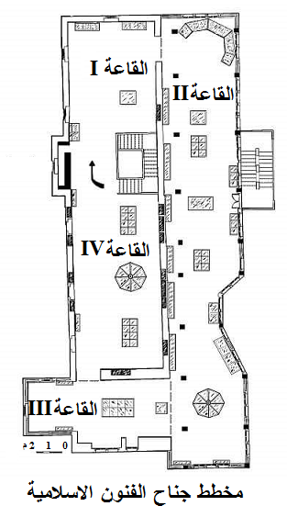In 1932, the museum was renamed the Stéphane Gsell Museum in honor of his scholarly contributions and dedicated efforts. Gsell was its director from 1902 to 1920. Mohamed Temmam became the **first Algerian director** of the museum upon his appointment in 1963. (N.Abdelouahab, 1997). By Executive Decree No. 85-297 (Official Gazette, 1985), it was classified as the **National Museum of Ancient Antiquities and Islamic Arts** and placed under the guardianship of the Ministry of Culture and Tourism.

**2-The Museum’s Treasures and Collections:**

Before detailing the artifacts and material heritage housed in the museum, it is essential to outline its structural organization. By Ministerial Joint Decree dated 29 Dhu al-Qi'dah 1407 AH (corresponding to July 25, 1987), the museum was structured into a **"Department of Research and Conservation of Antiquities".** (Laama, 2013-2014), comprising:

* Service for Research and Preservation of Ancient Antiquities
* Service for Research and Preservation of Islamic Antiquities.
* Department of Promotion and Documentation*(*Library - Archives - Promotion and Publications - Photography).
* Administrative Service*,* including the Personnel and Social Affairs Division*.*
* General Resources Division*and*Security Division*.*

The main buildings within the grounds of the National Museum of Ancient Antiquities and Islamic Arts consist of three sections: the **Ancient Antiquities section**, the **Islamic Arts section**, and the **Library** located on the ground floor, while the first floor is devoted to the General Administration. The Library Service was established in 1985 and holds documentary resources on Islamic history and archaeology, including photographs, maps, and over **4,705 titles.** (Laama, 2013-2014)**, they are ;**  1,785 in Arabic and French, and 2,595 in other languages – along with 25 periodicals

This building is divided into several thematic galleries like: Bronze Hall, Christian Art Hall, Funerary Cinerary Urns Hall, Marble Sculptures Hall, Pagan Religions Hall, Icosium Hall, Numismatics Hall, Pottery Hall, Central Courtyard( <http://www.musee-antiquites.art.dz>). In **Marble Sculptures Hall** , we find Roman-era marble statues of deities and emperors, alongside diverse mosaics depicting mythological scenes and geometric motifs while **Funerary Cinerary Urns Hall** Variously shaped urns in pottery and ivory containing sacred ashes, along with Christian-era lamps. The **Christian Art Hall** includes a sarcophagus engraved with miracles of Jesus Christ, numerous mosaics, and the Lambaesis Irrigation Stele*from* Mrouana. We also find bronze artifacts in **Bronze Hall**.

**While the Islamic part in the first floor includes**  Numismatics Hall (inaugurated April 25, 2007) displays coinage from Algeria’s historical periods, with the oldest dating to the 4th century BCE, the second floor **includes** Four galleries that are as follow :

**- Gallery 1**: Artifacts from the Beni Hammad Citadel, the Almoravid-era minbar (pulpit) of the -Great Mosque of Algiers, and a Mamluk glass lamp.

**- Gallery 2**: The Great Mosque’s Quran, swords, pistols, and other artifacts (16th–19th century).

**- Gallery 3**: Items from Morocco and Tunisia, and 19th-century Algerian carpets.

**- Gallery 4**: Pottery vessels, jewelry collections, and miniatures by the late artist Mohamed Temmam.

**Recovered Artifacts (2007–2014) are found**

Through cooperation with the National Security, Gendarmerie, and Customs, the museum that retrieved diverse items including: Prehistoric flint arrowheads, Marble sculptures, firearms, chandeliers, Ancient and Islamic-era pottery, Bronze and ivory tools, An oil painting by artist Jean-François Millet (recovered 2014). An exhibition of these repatriated artifacts was held at the museum from May 10 to December 10, 2015, in collaboration with the Ministry of Culture where they displayed in the Antiquities Department an attractive artifacts like hunting scenes and methological depictions, yet the most tourist-attracting is Mosaics: Particularly the **Funerary Mosaic of Kherbet Ouled Arif (Lambiridi)** near Batna (discovered 1918, 3rd century CE) (A.Balu، 1919)), (J.Carcopino, 1922), (Derder(E), 1991) This mosaic depicts a doctor taking the pulse of the emaciated Cornelia Urbanilla, who died at age 28 years, 10 months, 12 days, and 9 hours according to her tomb inscription. (Mokkadem, 2011).

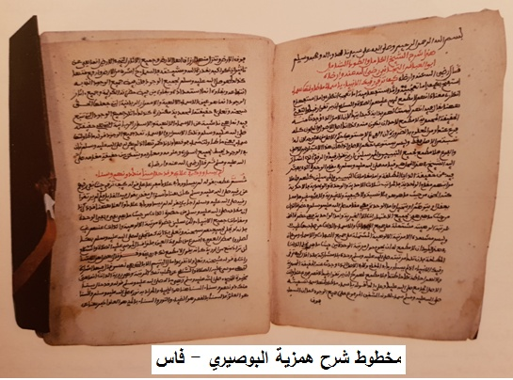Among the notable artifacts is the **marble Gorgon mask**, discovered in 1930 near the main square of Annaba, the mask was stolen from its original location—where it adorned the city’s fountain—on the night of March 4, 1996. It was smuggled into Tunisia but was eventually recovered in 2014 after an extensive investigation. The museum also has many other significant artifacts in its **Ancient Antiquities section**, which are valuable for historical research. These include the **Marwana irrigation tablet**, which provides insights into ancient water management systems, and the **Albertini Tablets**, which document aspects of daily life during the Vandal period. Additionally, there are numerous other treasures that visitors can admire, each offering a glimpse into the region’s rich past. However, to truly appreciate these artifacts—their intricate craftsmanship and historical importance one must visit the museum, as written descriptions alone cannot capture their full splendor.

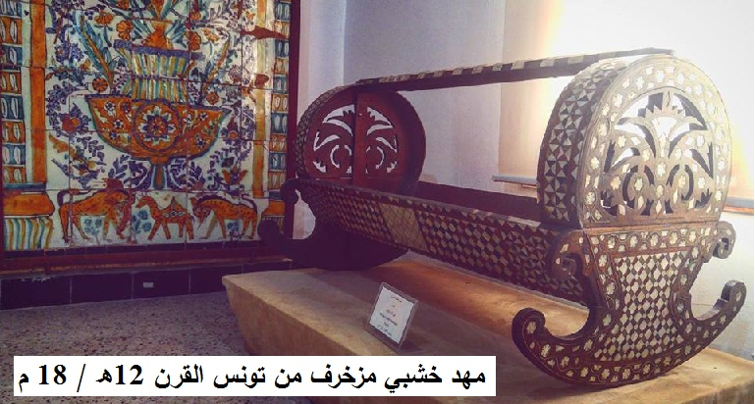 **Within the Islamic Arts part, notable exhibits include a Tunisian-crafted wooden infant cradle, the original door of the Ketchaoua Mosque, and a leather-bound manuscript of Sharḥ Hamziyyat al-Būṣīrī (Commentary on al-Būṣīrī’s Hamziyya). This manuscript was authored by Abū al-ʿAbbās Aḥmad ibn Muḥammad ibn al-Mukhtār al-Tijānī of Laghouat, who settled in Fes in 1803 and remained there until his death in 1815. The book’s measuring is 20.5 cm in height and 15 cm in width, the 97-page work is penned in Maghrebi script using black and red ink, offering a meticulous exegesis of al-Būṣīrī’s renowned poem "al-Hamziyya fī Madḥ Khayr al-Bariyya" (Algeria Heritage and Civilization , 2010). Besides, diverse galleries further display an array of artifacts—including jewelry, traditional women’s garments, ornately decorated ceramic vessels, equestrian equipment, historical weaponry, and wooden objects from various periods.**

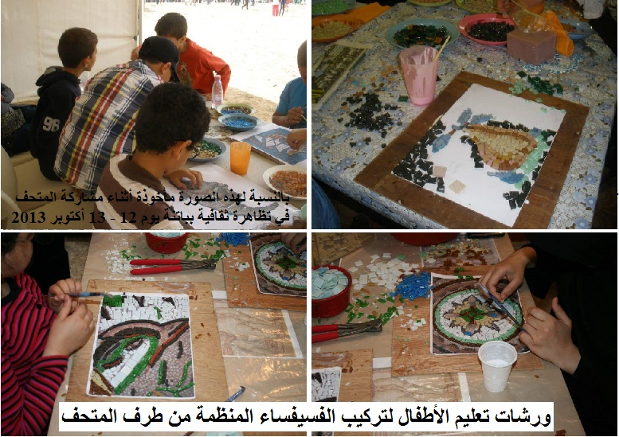**3- The Museum’s Role and Activities in Society**  
Museums serve as educational and cultural institutions for society while providing spaces for leisure and recreation. Today, they also function as pillars of economic support for nations seeking new avenues to bolster development through cultural tourism and heritage. In this context, I partially disagree with Professor Hamid Hamlaoui’s definition (Hamlaoui, H., 2016, p. 1) of museums as "non-profit" institutions – despite his valuable study emphasizing their role in proper socialization. His view aligns with the International Council of Museums (ICOM)’s seventh definition, which describes museums as "permanent institutions not-for-profit […] in the service of society" dedicated to "research, education, and enjoyment." (Hamid, 2016).

While no one denies that museums educate, enrich, and entertain communities, contemporary technological advancements and emerging fields – such as marketing, management, tourism, and museology – compel these institutions to evolve. Museums are no longer merely potential resources for future development (e.g., cultural tourism) or theoretical alternatives; they must truly contribute to society culturally, psychologically, and economically......, like other tourism-reliant nations.

The Museum of Ancient Antiquities and Islamic Arts strives to meet modern demands by enhancing its educational functions. Its team consistently organizes diverse exhibitions catering to both specialists and general visitors, including:A 2002 retrospective of late artist Mohamed Temmam (June 8–July 31), or like that Displays on Algerian history through coinage, An exhibition on 18th–19th-century Algerian equestrian art (September 9, 2012–January 30, 2013), including also The 2015 showcase of repatriated artifacts (May 10–December 10). The museum also hosts scholarly lectures, such as: "Ancient Myths Depicted in Artifacts of the National Museum" (Professor Ouheiba Lipaliden, March 26, 2014), "Scholars of North Africa in Antiquity" (Professor Moussa Zemouli, October 15, 2014), "North Africa Prior to the Arab Conquest" (Nassira Ben Seddik, April 23, 2014).

However, a significant shortfall remains; the inadequate promotion of these events. Insufficient publicity often prevents interested audiences from learning about lectures or exhibitions before or during their occurrence.

Complementing these exhibitions, the Museum’s Program Animation Team has launched a noteworthy initiative: weekly mosaic and ceramic workshops. Held every Tuesday for children and Wednesday for adults, these hands-on, educational activities combine intellectual engagement with manual skill development. Requiring focus and creativity, the workshops entertain while educating participants of all ages, fostering personal positivity and helping individuals discover future hobbies. They also cultivate a spirit of collaboration among attendees—an experience that often instills lasting optimism.

Regarding the lists of visitors, analysis of museum attendance records (2012–2014 statistics sourced from the Ministry of Culture’s Statistical Guide by the Sub-Directorate of Archives, Documentation, Statistics), and IT; 2015–2017 data obtained from the museum’s Engagement Office), or through the two diagrams, reveals a modest increase in visitors from different ages. Notably, the majority are local rather than international tourists—unlike many other countries. This likely reflects evolving public attitudes among Algerians and growing interest in leisure-oriented cultural experiences.

Consequently, museum activities should be leveraged as it is located within the serene Garden of Freedom. Initiatives could include dedicating gallery space to emerging painters, sculptors, and creators who lack access to financially prohibitive exhibition venues. Such programs would broadly increase museum footfall while generating meaningful revenue. This income would empower the institution to achieve financial sustainability and actively contribute to Algeria’s cultural and economic development.

Table 01: Museum Schedule for National Museum of Ancient and Islamic Antiquities from 2012 to 2017

|  |  |  |  |  |  |  |
| --- | --- | --- | --- | --- | --- | --- |
|  | **2012** | **2013** | **2014** | **2015** | **2016** | **2017** |
| **School groups** | 1214 | 1812 | 1448 | 857 | 612 | 773 |
| **Official delegation** | 22 | 102 | 412 | 244 | 72 | 153 |
| **Local visitors** | 2119 | 1610 | 2247 | 3704 | 2721 | 4072 |
| **Foreign visitors** | 830 | 712 | 307 | 242 | 373 | 502 |
| **Total** | 4185 | 4236 | 4414 | 5065 | 3778 | 5500 |

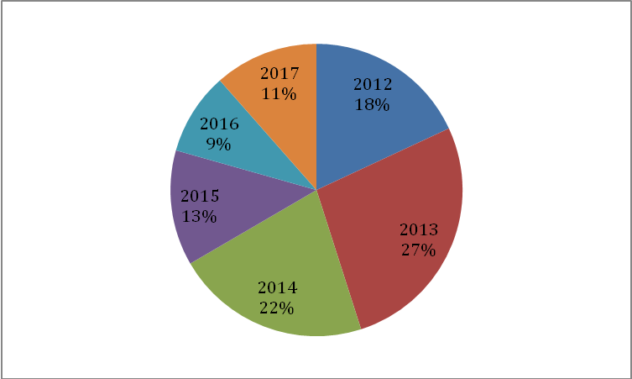



**Globally, museums increasingly prioritize their tourism role to generate profitability that enable operational autonomy beyond government funding. This shift has driven institutions worldwide to develop strategic plans enhancing their societal impact. Numerous studies highlight the museum-tourism relationships. (Atif, 2014), tracing scholarly attention to Benjamin Gilman's seminal 1916 article addressing "physical fatigue and psychological strain in museums." , like Jean Capart further advanced exhibition design through research beginning in 1929. Systematic studies proliferated across Canada, the United States, Britain, France, Germany, and other museology-focused nations starting in the 1970s (Alrazki, 1997) , examining museums' pedagogical effectiveness for visitors.**

**The 1970s marked an intellectual renaissance in museology, catalyzing evolved institutional philosophies centered on visitor engagement. (Dormaels, 2008). Implementing this paradigm requires redefining the contemporary "museum mission" while advancing pedagogical and practical methodologies. These innovations empower institutions to fulfill their societal roles effectively (Dormaels, 2008). By shifting focus to visitors, museums can harmonize dual priorities: conserving collections while serving diverse audiences—from leisure-seeking tourists to specialized researchers.**

**Achieving this balance demands creative museum marketing strategies to increase attendance and leverage visitor interests for developmental goals. Key enablers include improving transportation access and ensuring affordability. Museum administrations must actively engage with current scholarship on museum policy and practice, implementing researcher-proven methods for optimizing institutional impact. To remain competitive with regional and global peers in revenue generation, Algerian museums should prioritize investment and establish specialized departments. (Khrouf Mounir, 2016). Such units would design and execute marketing programs to maximize utilization of museum spaces.**

**Recommendations:**

* **Coordination with Tourism Agencies:** Establish partnerships to organize domestic tours and museum visits across Algeria. The current lack of such coordination explains the low foreign visitor rates reflected in attendance data.
* **Dynamic Digital Presence:** Prioritize daily updates to the museum’s website, featuring events, activities, and exhibitions. This serves not only to attract visitors but also supports researchers and students specializing in museology or cultural tourism. In today’s digital age, online platforms are critical for engaging both local and international audiences.
* **Reaffirming Core Educational Mission ;** Integrate museum visits into itineraries for local and foreign tourists, emphasizing the institution’s role in education, cultural identity reinforcement, and civic awareness.
* **Enhanced Visitor Guidance ;** Provide trained cultural mediators and audio guides to contextualize exhibits, as display placards alone are often insufficient for understanding artifacts’ historical periods.
* Produce and market high-quality replicas of museum treasures to boost institutional income.
* Maintain a sales kiosk during all opening hours, offering museum publications, postcards, scaled statues, replica pottery, and mosaic-inspired artworks.
* Launch mobile exhibitions in schools and public spaces to demystify museums. Many citizens remain unaware of visiting hours or collections, often due to psychological barriers. Direct public engagement can spark interest in recreational or educational visits—individually, in groups, or as family activities.
* Promote exhibitions and programs through radio and national television, supplementing digital channels. Social media alone fails to reach older demographics, general citizens, and even specialists less active online.
* Integrate museology and heritage awareness into national school curricula to cultivate future generations who value cultural diversity, understand their history, and cherish their identity.

**Conclusion**

While Algeria still lags in leveraging museums for tourism promotion and economic diversification, emerging efforts offer hope. Encouraging initiatives by cultural authorities, particularly educational visits for schoolchildren, the citizens of tomorrow—signal a shift toward cultural awareness. Nurturing this generation through historical values, aesthetic appreciation, and artistic engagement, especially when guided by experts in pedagogy, child psychology, and museology, lays the foundation for a future where museums actively contribute to national development.

**References**

A.Balu. (1919). *Mosaique de Lambiridi ,BCTH,.*

Abd Al-Raham Laama. (2013-2014). The Educational Role of Algerian Museums: A Case of National Museums. *Doctoral Dissertation* . Tlemcen-Algeria، University of Abou Bakr Belkaid.

Akram Rawachdah Atif. (2014). The Role of Jordanian Museum in Attracting Tourism. *Dirassat Human and Social Sciences* .

Algeria Heritage and Civilization . (2010). Collections of the National Museum of Antiquiyies.

Bent Nabi Mokkadem. (2011). *Medicine and the Use of Plants in Ancient Maghreb, Wiews and Studies in History and Ancient Archaeology- Proceeding of the Scientific Conference held at the Superior Teacher's School.* Bouzeriah- Algeria.

Derder(E). (1991). Les mosaiques du musée national des antiquuités d’Alger-etude descriptive,Annales M .N.A.

Deriass Lakhdar. (1991). Annals of the National Museum of Achaeology. (the first).

Fariha Linda Khrouf Mounir. (2016). Museums in Algeria and their Role in Tourism. *National Conference: Museum and Sciety;from understanding reality to shaping the future* . Skikda University- Algeria.

Hamlaoui Hamid. (2016). Sociological Dimentions of Museum Education: The Role of Museum in Algeria's Tourism. National Conference on Museum and Society Bridging the Past to Shape the Future، Skikda University-Algeria.

J.Carcopino. (1922). *Mosaique de Lambiridi.*

K.Gachi-Djama,A.Soltani N.Abdelouahab. (1997). Hommages aux conservateurs du musée national des antiquités depuis sa creation jusqu’en 1988. *Annales du musée national des antiquités* (N°6).

Mathieu Dormaels. (2008). *Rôle social des musées : une autre « nouvelle » muséologie. Muséologies.*

P.Cavault. (1894). Notice sur la bibliothèque – Musée d’Alger, Revue Africaine. *38*.

Sharki Alrazki. (1997). THe Impact of Exhibition on the Pedagogical Outcome of the Museum towards its Visitors. *Annals of the National Museum of Antiquities* .